Cloud integrated Authentication with Posture check & UAT

Document No: 20Jul2025 A

AUTHENTICATION WITH POSTURE UAT Document

Document Control
Action | Name | Date
Author |  | 28th June 2019
Author |  | 20th July 2019
Version
Version | Date | Change | Affected Pages | Remark
1.0
2.0 |  | Updated in ISE
3.0 |  | Updated

Distribution List
Name | Organization | Title

Only Distributed to Distribution List.

Contents
Introduction 4
Authorization and Authentication Tools and Processes 4
Part I - Posture Based Authorization 5
1. Image Based Posture Check for Domain Joined Client 5
1.1 Posture for OS Build 5
1.2 Posture for Hotfix 6
1.3 Posture for Services 6
1.4 Posture for Ant-Virus 7
2. Cisco ISE Based Posture Check for Non–Authenticated / Authenticated computer 9
2.1 ISE Configuration Steps 9
2.2 Posture Condition Configured on Cisco ISE 9
2.3 ISE to Client Communication Flow 10
2.4 ISE Checklist 11
2.5 Posture Profile Configured on Cisco ISE 11
2.5.1 BYOD (Guest) 11
2.5.1.1 Guest CWA Posture (NAC Web Agent) 11
2.5.2 Authenticated Users 15
2.5.2.1 GIC Employee Dot1x Posture (NAC Agent) 15
2.5.3 Non-Authenticated Users 19
Part II – Domain Based Authentication 19
2 GIC Domain Client Authentication 19
2.1 Kerberos TGT (Authentication or Logon Ticket) Process 20
2.2 TGT format (TGS is similar): 20
2.3 Kerberos TGS (Service Ticket) Process 21
3 GIC Single Sign on for Hybrid applications. 21
3.1 Azure AD Pass-through Authentication. 22
3.2 Azure Multi Factor Authentication. 24
Part III – Intune Based Authorization 25
Device /User Groups 25
Device Compliance policy 25
PIN or password configuration 25
Application Restriction policy 26

Introduction
This document represents the recommendations of Hilal Computers for Authentication Flow and Posture Check for Different kind of user Devices (BYOD, Authenticated and Non-Authenticated). These Configuration are based upon Bipeen Sinha ( Consultant) formidable experience and understanding of Enterprise Computing. Substantial time and effort was spent collecting requirements and feedback from the IT to ensure that all the stakeholder’s needs were represented and taken in to consideration.

Authorization and Authentication Tools and Processes
Tool/ Processes | URL | Description
Cisco ISE | https://www.cisco.com/c/en/us/products/security/identity-services-engine/index.html | We use Cisco ISE to Validate the Posture Of Different Devices
Cisco NAC | https://www.cisco.com/c/en/us/products/security/what-is-network-access-control-nac.html | Network access control, or NAC, solutions support network visibility and access management through policy enforcement on devices and users of corporate networks.
Group Policy Object (GPO) |  | We Use Local Group Policy to harden the server
On-Prem Active Directory
Azure Active Directory |  | Azure Active Directory (Azure AD) is Microsoft's cloud-based identity and access management service, which helps your employees' sign in and access resources in: External resources, such as Microsoft Office 365, the Azure portal, and thousands of other SaaS applications.
Azure AD Connect | https://docs.microsoft.com/en-us/azure/active-directory/hybrid/how-to-connect-pta
Azure MFA | https://docs.microsoft.com/en-us/azure/active-directory/authentication/concept-mfa-howitworks
PowerShell Script |  | We use PowerShell script to check Posture for image based client Deployment
Windows Services |  | We use Window Services to Harden the unnecessary services
Microsoft Intune |  | We are using intune to Protect only Mobile devices

Authentication and Authorization

Part I - Posture Based Authorization

Image Based Posture Check for Domain Joined Client
Operating system Image will deploy to all the Enterprise Client of GIC. This Image will include the posture of OS Build Version, Hotfix Detail, Services State, and Anti- Virus state. Image based Posture will be validated against reference image with image based posture on client using PowerShell startup script. We are using the group policy based script to validate the posture of domain joined client.

Following posture will be validated for posture compliance and authorization of the domain joined Clients during booting up process using system.ini Configuration

Posture for OS Build
Operating system Image will deploy to all the Enterprise Client of GIC. This Image will include the posture of OS Build Version. Image based Posture will be validated against reference image with existing hotfix install on client using following PowerShell start script

# OS Build Version Posture Check

Remove-Item "c:\PS\OSLocal.txt"

Reg Query "HKLM\SOFTWARE\Microsoft\Windows NT\CurrentVersion" /v ReleaseId >>c:\PS\OSLocal.txt

$c = Compare-Object -ReferenceObject (get-content C:\PS\OSRef.txt) -DifferenceObject (get-content c:\PS\OSLocal.txt )
$counter1 = 0
:OS foreach ($grp1 in $c)
{

if ($grp1.SideIndicator -eq "=>") {

$counter1++
Write-Host " PC is Compliante for OS Build "
}

else
{
$grp1
$MessageboxTitle = “WARNING:Your PC is not Compliant”
$Messageboxbody = “Please Contact GIC HelpDekp:OS Build Error”
[System.Windows.MessageBox]::Show($MessageboxTitle,$Messageboxbody,'OK','Error')

break :update
}
}

Posture for Hotfix
Operating system Image will deploy to all the Enterprise Client of GIC. This Image will include the posture of Hotfix Version. Image based Posture will be validated against reference image with existing hotfix install on client using following PowerShell start script.

# Windows Update Posture Check

Remove-Item "c:\PS\updatlocal.txt"
get-hotfix -description "Security Update" >>C:\PS\updatlocal.txt

$d=Compare-Object -ReferenceObject (get-content C:\PS\updateref.txt) -DifferenceObject (get-content C:\PS\updatlocal.txt)

$counter2 = 0
:update foreach ($grp2 in $d)
{

if ($grp2.SideIndicator -eq "=>") {

$counter2++
}

else
{
$grp2
$MessageboxTitle = “WARNING:Your PC is not Compliant”
$Messageboxbody = “Please Contact GIC HelpDekp:Windows Hotfix Error”
[System.Windows.MessageBox]::Show($MessageboxTitle,$Messageboxbody,'Ok','Error')

break :update
}
}

Posture for Services
Operating system Image will deploy to all the Enterprise Client of GIC. This Image will include the posture of Services installed and Its State. Image based Posture will be validated against reference image with existing Services install on client using following PowerShell start script.

# Services Posture Check
Remove-Item "c:\PS\serviceslocal.txt"

Get-Service |Select-Object -Property Name,DisplayName,Status,StartType |Where-Object {$_.StartType -eq "disabled"} >>c:\PS\serviceslocal.txt

$b = Compare-Object -ReferenceObject (get-content c:\PS\servicesref.txt) -DifferenceObject (get-content c:\PS\servicesLocal.txt)
$counter = 0
:first foreach ($grp in $b)
{

if ($grp.SideIndicator -eq "=>") {

$counter++
}

else
{
$grp
$MessageboxTitle = “WARNING:Your PC is not Compliant”
$Messageboxbody = “Please Contact GIC HelpDekp : Service StartType Error ”
[System.Windows.MessageBox]::Show($MessageboxTitle,$Messageboxbody,'Ok','Error')

break :another
}

Posture for Ant-Virus
Operating system Image will be deployed on all the Enterprise Clients of GIC. This Image will include the posture of Anti-Virus installed and Its State. Image based Posture will be validated against reference image with existing Anti-Virus install on client using following PowerShell start script.

# Antivirus Build Posture Check
Remove-Item "c:\PS\AVlocal.txt"
WMIC /Node:localhost /Namespace:\\root\SecurityCenter2 Path AntiVirusProduct Get displayName /Format:List >>C:\PS\AVLocal.txt
$e= Compare-Object -ReferenceObject (get-content C:\PS\AVref.txt) -DifferenceObject (get-content C:\PS\AVLocal.txt)

$counter3 = 0
:AV foreach ($grp3 in $c)
{

if ($grp3.SideIndicator -eq "=>") {

$counter3++
}

else
{
$grp3
$MessageboxTitle = “WARNING:Your PC is not Compliant”
$Messageboxbody = “Please Contact GIC HelpDekp:Windows Hotfix Error”
[System.Windows.MessageBox]::Show($MessageboxTitle,$Messageboxbody,'Ok','Error')

break :AV
}
}

The policy will apply during computer startup. Below is the flowchart of how policy will check the posture check of the client computer in GIC Domain.
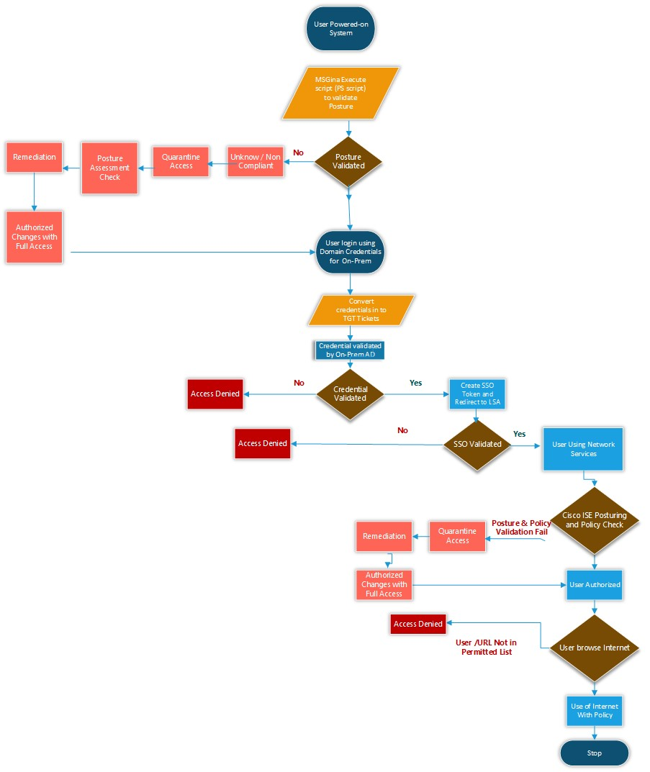

Cisco ISE Based Posture Check for Non–Authenticated / Authenticated computer

ISE Configuration Steps
- Configure and deploy client provisioning services.
- NAC Agent: Persistent posture agent for Windows client PCs.
- Mac OS X Agent: Persistent posture agent for Mac OS X client PCs.
- Web Agent: Temporal posture agent for Windows only PCs.
- Compliance Module: OPSWAT module that provides updates to current AV/AS vendor support for both the NAC Agent and Mac OS X Agent. Not applicable to Web Agent.
- Profiles: Agent configuration files for NAC Agent and Mac OS X Agent.
- Updates locally installed XML files on client PCs. Not applicable to Web Agent.
- Configure authorization policies.
- Configure posture policies.

Posture Condition Configured on Cisco ISE

Below Posture Check will be configured on Cisco ISE

- Anti-Malware Condition
- Approved Antivirus
  - Symantec Web Client
- Approved Antivirus updates
- Anti-Spyware Condition
- Application Condition (Applications not listed in Office use)
  - Microsoft Office
  - Acrobat Reader
  - ISE AnyConnect
  - SAP Client
  - Java 8
  - Silverlight
  - WinRAR
  - OneDrive for Business
  - Umbrella Agent
  - Barracuda Agent
  - Zoho Remote Client
  - ShareX
  - Dell SonicWall VPN
  - O365 Company Portal
  - OEM Management Software
  - Patch Management Condition
  - Approved OS Hotfixes
  - Approved OS patches
  - OS Security updates
  - Service Condition
  - Any Services which are not the part of the original image

ISE to Client Communication Flow
- NAC Agent and web agent files are downloaded to ISE
- Before posture assessment policies and requirement are configured, the authorization policy is updated to apply authorization profiles to guest users that are flagged as non-compliant
- Try new authorization profile defined in this configuration limits access to posture and remediation resources
- Employed and guest user flagged as complaint are allowed regular network access
- Once client provisioning services has been verified, posture requirement is configured on order to check for antivirus installation, virus definition update and windows critical update Below profile will be configured Cisco ISE

Note : If a firewall exists locally on the client or along the network path to the ISE, you must open these ports for ISE NAC communication:
- UDP/TCP 8909: Used for client provisioning.
- UDP/TCP 8905: Used for posture communication between NAC Agent and ISE (Swiss port).
- TCP 8443: Used for guest and posture discovery.

Note : Client must be allowed to access these sites, so these URLs must not be redirected:
- http://windowsupdate.microsoft.com
- http://*.windowsupdate.microsoft.com
- https://*.windowsupdate.microsoft.com
- http://*.update.microsoft.com
- https://*.update.microsoft.com
- http://*.windowsupdate.com
- http://download.windowsupdate.com
- http://*.download.windowsupdate.com
- http://wustat.windows.com
- http://ntservicepack.microsoft.com
- http://stats.microsoft.com
- https://stats.microsoft.com

ISE Checklist
- Navigate to Administration > External Identity Sources > Active Directory, and verify that ISE is joined to the Active Directory (AD) domain.
- Click the Groups tab, and verify that the Domain Users group is added to AD configuration.
- Navigate to Administration > Network Resources > Network Devices, and verify that the switch and WLC are defined as Network Access Devices (NAD).
- Under Policy > Authentication, ensure the dot1x and MAC Authentication Bypass (MAB) rules are configured as described here:

- Dot1x authentications for wired and wireless clients are sent to AD Identity Store.
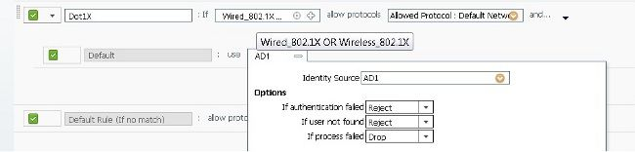

Posture Profile Configured on Cisco ISE

BYOD (Guest)
All the who is using their own personal Devices will be validated with ISE for Posture Check before allowing them to access the network

Guest CWA Posture (NAC Web Agent)
This is the procedure that users perform, once they connect to the guest SSID with posture enabled.
- Connect to your Guest SSID, or do not configure dot1x on your wired network.
- Open a browser and try to navigate to a site.
- The browser is redirected to the guest portal.
- Click Self registration, and proceed with authentication.
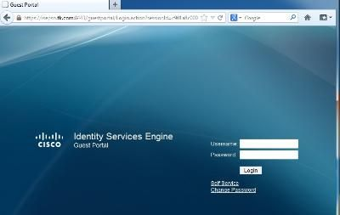

- Click Accept in order to accept the AUP.
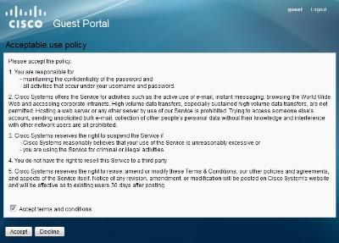

- Select Click to install agent.
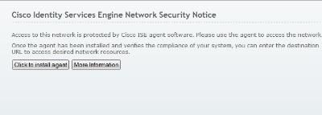

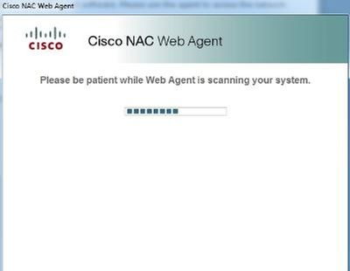

- Select Click to install agent.
- If the PC Compliant you should see this message
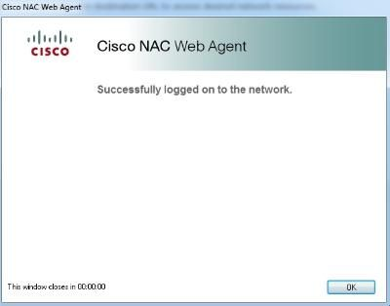

- If the PC is not Compliant you should see this message
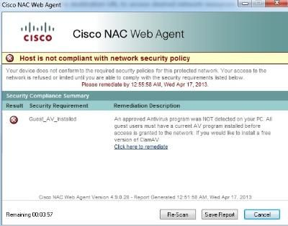

- Need to remediate first

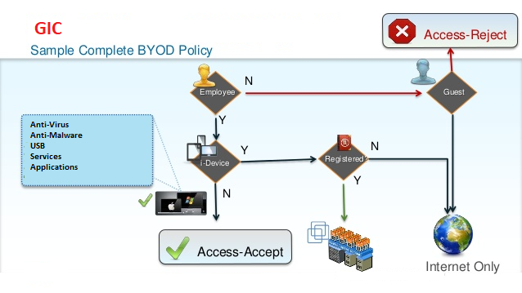

Authenticated Users

All the Users who is using GIC Domain Joined Client with approved OS Image will be validated with image based posture Check and then get Authenticated with Active Directory and then ISE for Posture Check before allowing them to access the GIC Enterprise network.

GIC Employee Dot1x Posture (NAC Agent)
- This is the procedure of the posture itself from a client perspective, once the client connects to the WLANs previously configured.
- Configure your wireless SSID (employee) or wired network for PEAP MSCHAP V2, and connect with an AD user in the domain user group.
- Open a browser, and try to navigate to a site. A redirect prompt is displayed.
- Click Click to Install Agent.
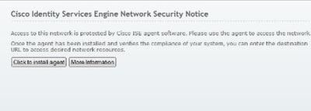
- Click Next.
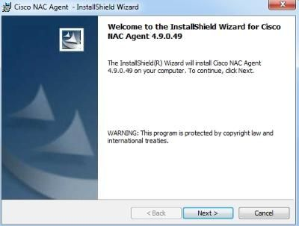
- Click Next., Accept the License Agreement
- Click Complete, and click Next.
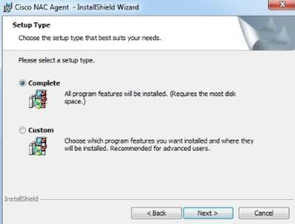
- Click Install

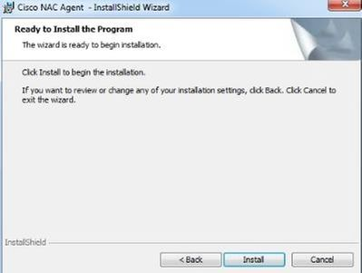

- Click Finish.
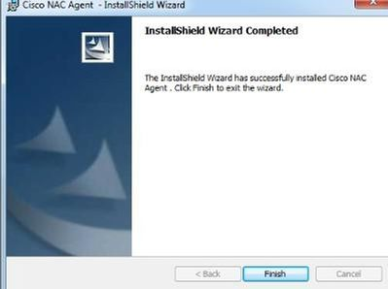
- Once installation is complete, the NAC Agent pops up. Click Show Details.
- If the PC is compliant it show below message :
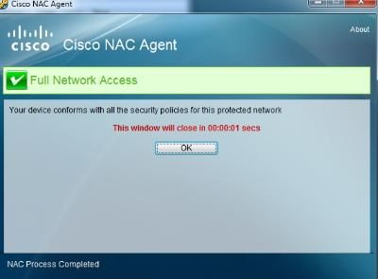

- If the PC is Not compliant it shows below message:

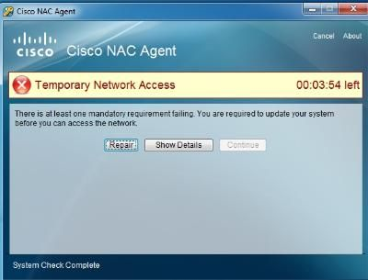

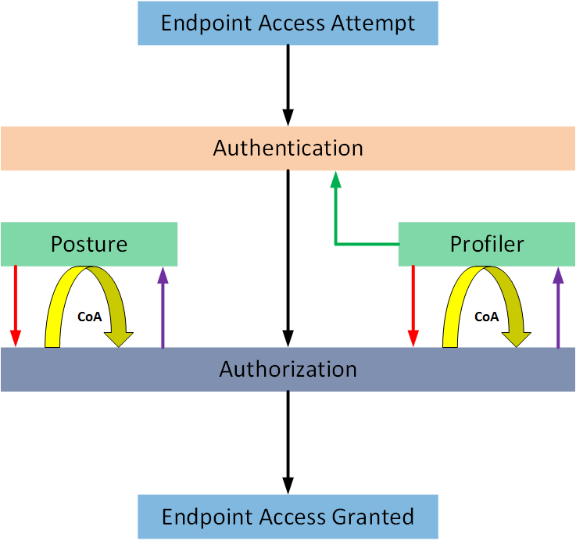

Non-Authenticated Users
All the Users who belong to GIC Organization but their devices are not part of GIC Enterprise Domain and not have approved GIC OS Image, will be validated with ISE for Posture Check before allowing them to access the GIC Enterprise network.
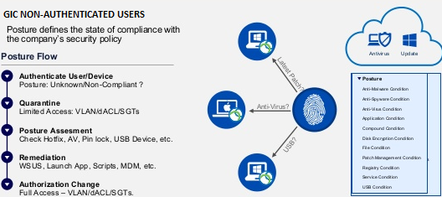

Part II – Domain Based Authentication

GIC Domain Client Authentication
GIC Domain use Kerberos for authentication and Kerberos communication within a domain is pretty straightforward – the domain Kerberos service account is used to sign and encrypt every authentication ticket (TGT). This enables the TGT to be used throughout the domain and presented to any DC in the domain.
When a user authenticates to Active Directory, the authenticating Domain Controller creates a TGT (authentication ticket) for the user that contains the groups the user is a member of (including groups from other domains in the forest, such as universal groups), signs, and encrypts the ticket using the KRBTGT password hash. When presented later to the DC for a service ticket (TGS), the TGT ticket and its contents are validated. The DC effectively copies the contents of the TGT into a TGS (service ticket) that the user presents to the target service. One component of the TGS is encrypted with the target service’s password hash and the other with the user’s password hash. If the target service can open the TGS, it is accepted. This means that the user’s TGT can be reused to get service tickets during the TGT’s lifetime (10 hours by default).

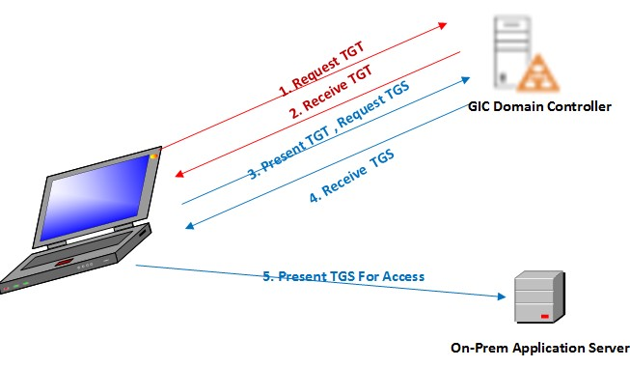

Kerberos TGT (Authentication or Logon Ticket) Process
- User logs onto the workstation with Domain credentials.
- The user’s password is converted to hash
- AS-REQ: Authentication request sent to Domain Controller.
- AS-REP: The KDC verifies Authentication Data and replies with TGT.

TGT format (TGS is similar):
- Client information – workstation FQDN & IP address
- User Restrictions – logon schedule, workstation restrictions, etc.
- Domain Kerberos Policy - Ticket Lifetime (Default: 10-hour lifetime & 7 day max)
- Ticket Flags – Encryption, ticket type (impersonation, can it be delegated, etc)
- Auth Data - PAC
  - User Info: User name, user SID, profile info, etc
  - Group Membership: Group RIDs
  - PAC Signature
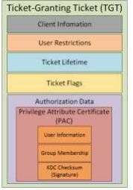

Kerberos TGS (Service Ticket) Process
- TGS-REQ: Client sends the TGT to the DC requesting a TGS for a specific service.
- Domain Controller validates the TGT by opening & validate checksum.
- DC looks up the Service Principal name for the Kerberos service in the TGS-REQ and identifies the associated Service Account.
- The DC creates a TGS ticket based on data in the TGT and encrypts it with the Service Account password hash.
- TGS-REP: DC sends the TGS to the client.
Note that a TGS has a server component & user component.

GIC Single Sign on for Hybrid applications.
As we have analyzed the environment has hybrid and cloud applications mix to manage for users, to ensure the authentication that enables application access securely and seamlessly we will ensure the single sing on is a compulsory requirement.
Users in ASU Enterprise location will be using the Active directory to authentication, for cloud office 365 users we ensure that we will be integrating Azure Active directory with seamless pass-through authentication.
Note: All application that authenticates must be certified for singe sign on capabilities, rather some dos or PowerShell based application or thick client application may require developer intervention. This will not be a part of its scope of deployment if this is the case.

Azure AD Pass-through Authentication.
Azure Active Directory (Azure AD) Pass-through Authentication allows your users to sign in to both on-premises and cloud-based applications using the same passwords. This feature provides your users a better experience - one less password to remember, and reduces IT helpdesk costs because your users are less likely to forget how to sign in. When users sign in using Azure AD, this feature validates users' passwords directly against your on-premises Active Directory.
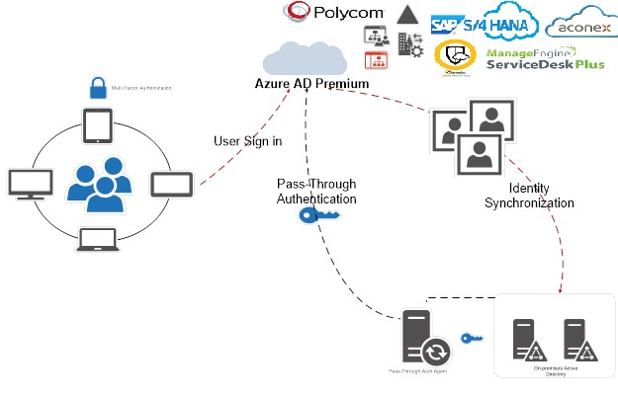
The agent for azure sync client will be installed ether in AD or AD sync server to ensure high availability, once the initial AD Sync performs after when your users are accessing applications on their corporate machines inside your corporate network, they don't need to type in their passwords to sign in.
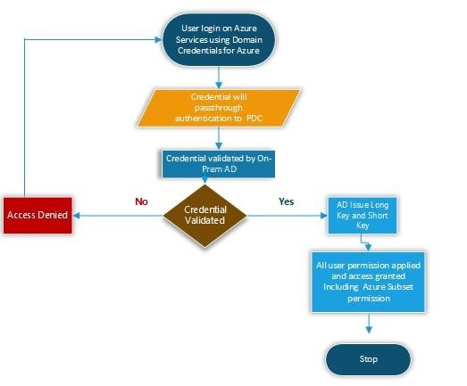
- User login to portal.ofice.com using its UPN
- The request redirect to login.microsoftonline.com
- The login.microsoftonline.com send the 401 to browser since it is pass through
- The browser sends the request to on-prem domain controller
- The domain controller validates the request and issues claim token
- The claim token then sends to Azure active directory and which decrypt it and grant logon permission
Note: Existing Hybrid configurations must be identical to the current active directory and validated azure domain for this type of authentication. Also, we have been notified by GIC that the Azure AD will be with premium capabilities.

Azure Multi Factor Authentication.
In this Deployment we will be deploying azure MFA in cloud and users who will be using the cloud applications will be authenticated with Azure MFA
Azure MFA support mobile based code OTP and SMS OTP and Email based OTP for users.
MFA Authentication Cycle.
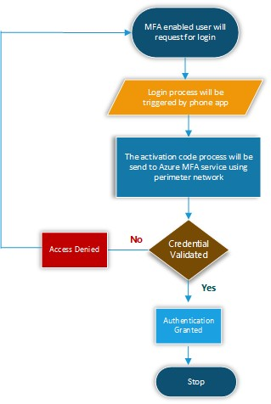
Note: No On-premises MFA Servers implemented at this Phase of the deployment.
Azure MFA will be a part of Hosted application deployment, detailed deployment procedure included in Hosted applications section.

Part III – Intune Based Authorization
As the GIC network is well connected by high speed network links all Users are already using Office 365 and in the Azure AD. We will deploy and Configure Intune on all mobile devices which is not part of AD Domain the below listed feature and Policies.

Device /User Groups
Groups are used to manage your users and control your employees' access to your company resources. Intune provides pre-created All Users and All Devices groups in the console with built-in optimizations for your convenience.

Device Compliance policy

PIN or password configuration - Disabled
Setting name | Policy
Require a password to unlock mobile devices
Simple passwords:
Minimum password length
Required password type
Number of non-alphanumeric characters in password:
Maximum minutes of inactivity before password is required
Password expiration (days):
Number of previous passwords to prevent reuse:

Application Restriction policy

Setting name |  | Mac |  | iOS | Android | Android for work | Windows
Restricted apps list | x |  | x |  | x |  | Windows Phone  8.1

Microsoft Application Management

Category |  | MAM Android Setting |  | Settting description
Data relocation settings |  | Allow app to transfer data to other apps |  | Specify what apps can receive data from this app:  Policy managed apps: Allow transfer only to other policymanaged apps.  All apps: Allow transfer to any app.  None: Do not allow data transfer to any app, including other policy-managed apps.
 |  | Prevent "Save As" |  | Choose Yes to disable the use of the Save As option in this app. Choose No if you want to allow the use of Save As.  Note: This setting is supported for Microsoft Excel,  OneNote, PowerPoint, and Word. It may also be supported by 3rd party and LOB apps.  Select which storage services corporate data can be saved to  Users are able to save to the selected services (OneDrive for Business, SharePoint, and Local Storage). All other services will be blocked.
 |  | Restrict web content to display in the Managed Browser |  | Choose Yes to enforce web links in the app to be opened in the Managed Browser app.
 |  | Disable contact sync |  | Choose Yes to prevent the app from saving data to the native Contacts app on the device. If you choose No, the app can save data to the native Contacts app on the device.
 |  | Disable printing |  | Choose Yes to prevent the app from printing work or school data.
Access settings |  | Require corporate credentials for access |  | Choose Yes to require the user to sign in with their work or school account instead of entering a PIN for app access. When set to Yes, and PIN or biometric prompts are turned on, both corporate credentials and either the PIN or biometric prompts will be shown.
 |  | Block managed apps from running on jailbroken or rooted devices |  | Choose Yes to prevent this app from running on jailbroken or rooted devices. The user can continue to use this app for personal tasks, but must use a different device to access work or school data in this app.
 |  | Block screen capture and  Android Assistant  (Android 6.0+) |  | ÛSelect Yes to block screen capture and the Android Assistant capabilities of the device when using this app. Choosing Yes will also blur the App-switcher preview image when using this app with a work or school account.
 |  | Require minimum Android operating system |  | Select Yes to require a minimum Android operating system to use this app. The user will be blocked from access if the Android version on the device doesn't meet the requirement.
 | Require minimum Android  operating system (Warning only) |  | Select Yes to require a minimum Android operating system to use this app. The user will see a notification if the Android version on the device does not meet the requirement. This notification can be dismissed.
 | Require minimum app version |  | Select Yes to require a minimum app version to use the app. The user will be blocked from access if the app version on the device does not meet the requirement.  As apps often have distinct versioning schemes between them, create a policy with one minimum app version targeting one app (for example, Outlook version policy).
 | Require minimum app version (Warning only) |  | Select Yes to recommend a minimum app version to use this app. The user will see a notification if the app version on the device does not meet the requirement. This notification can be dismissed.
 | Require Minimum Android Patch Version |  | Select Yes to require a minimum Android security patch released by Google. The user will be blocked from access if the Android security patch on the device does not meet the requirement.
 | Require Minimum Android  Patch Version (Warning  Only) |  | Select Yes to require a minimum Android security patch released by Google. The user will see a notification if the Android security patch on the device does not meet the requirement. This notification can be dismissed.
User Acceptance Test
UAT Parameter | Validation Process | Pass/Fail
MFA Authentication | 1. Cloud User open portal.Office.com and type their UPN  2. An SMS should come to user register mobile with code  3. User Enter the code and hit enter  4. User Should able to login on portal passcode is correct
Pass Through Authentication | 1. Cloud User open portal.Office.com and type their UPN  2. It should not ask the password of user if user login on GIC domain PC.  3. User Should able to login on portal with entering the password.
BYOD Posture Check | 1. Guest User connect with Wi-Fi  2. Down the ISE agent  3. ISE check the Posture  4. If posture check fail , it get quarantine IP and If pass it get Network IP
Image Based Posture Check | 1. Domain User Boot its Machine  2. Booting process check Image based Posture  3. If posture check fail , it get quarantine IP and If pass it get Network IP
Cisco ISE Posture | 1. Authentication User connect with Wi-Fi  2. ISE check the Posture  4. If posture check fail , it get quarantine IP and If pass it get Network IP

----------The End------------

